**Exercise 1: Configuring a Basic Spring Application**

**Scenario:**

Your company is developing a web application for managing a library. You need to use the Spring Framework to handle the backend operations.

**pom.xml**

<project xmlns="http://maven.apache.org/POM/4.0.0"

xmlns:xsi="http://www.w3.org/2001/XMLSchema-instance"

xsi:schemaLocation="http://maven.apache.org/POM/4.0.0 http://maven.apache.org/xsd/maven-4.0.0.xsd">

<modelVersion>4.0.0</modelVersion>

<groupId>org.example</groupId>

<artifactId>LibraryManagement</artifactId>

<version>1.0-SNAPSHOT</version>

<packaging>jar</packaging>

<name>LibraryManagement</name>

<properties>

<maven.compiler.source>17</maven.compiler.source>

<maven.compiler.target>17</maven.compiler.target>

</properties>

<dependencies>

<dependency>

<groupId>org.springframework</groupId>

<artifactId>spring-context</artifactId>

<version>6.1.6</version>

</dependency>

</dependencies>

</project>

**applicationContext.xml**

<?xml version="1.0" encoding="UTF-8"?>

<beans xmlns="http://www.springframework.org/schema/beans"

xmlns:xsi="http://www.w3.org/2001/XMLSchema-instance"

xsi:schemaLocation="http://www.springframework.org/schema/beans

<https://www.springframework.org/schema/beans/spring-beans.xsd>">

<bean id="bookRepository" class="com.library.repository.BookRepository" />

<bean id="bookService" class="com.library.service.BookService">

<property name="bookRepository" ref="bookRepository"/>

</bean>

</beans>

**BookRepository.java**

package com.library.repository;

public class BookRepository {

public String getBookName() {

return "Spring in Action";

}

}

**BookService.java**

package com.library.service;

import com.library.repository.BookRepository;

public class BookService {

private BookRepository bookRepository;

public void setBookRepository(BookRepository bookRepository) {

this.bookRepository = bookRepository;

}

public void displayBooks() {

System.out.println("Book: " + bookRepository.getBookName());

}

}

**App.java**

package com.library;

import com.library.service.BookService;

import org.springframework.context.ApplicationContext;

import org.springframework.context.support.ClassPathXmlApplicationContext;

public class App {

public static void main(String[] args) {

ApplicationContext context = new ClassPathXmlApplicationContext("applicationContext.xml");

BookService bookService = (BookService) context.getBean("bookService");

bookService.displayBooks();

}

}

**OUTPUT:**

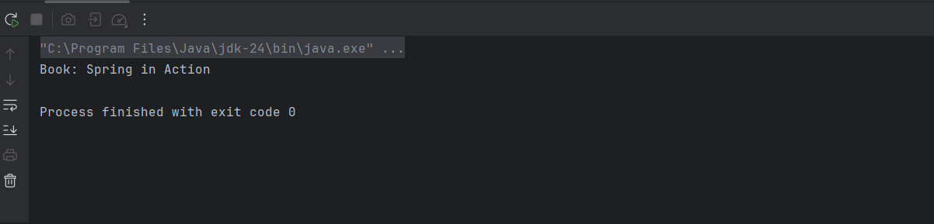

**Exercise 2: Implementing Dependency Injection**

**Scenario:**

In the library management application, you need to manage the dependencies between the BookService and BookRepository classes using Spring's IoC and DI.

**applicationContext.xml**

<?xml version="1.0" encoding="UTF-8"?>

<beans xmlns="http://www.springframework.org/schema/beans"

xmlns:xsi="http://www.w3.org/2001/XMLSchema-instance"

xsi:schemaLocation="http://www.springframework.org/schema/beans

https://www.springframework.org/schema/beans/spring-beans.xsd">

<bean id="bookRepository" class="com.library.repository.BookRepository" />

<bean id="bookService" class="com.library.service.BookService">

<property name="bookRepository" ref="bookRepository"/>

</bean>

</beans>

**BookService.java**  
package com.library.service;

import com.library.repository.BookRepository;

public class BookService {

private BookRepository bookRepository;

public void setBookRepository(BookRepository bookRepository) {

this.bookRepository = bookRepository;

}

public void displayBooks() {

System.out.println("Book: " + bookRepository.getBookName());

}

}

**App.java**  
package com.library;

import com.library.service.BookService;

import org.springframework.context.ApplicationContext;

import org.springframework.context.support.ClassPathXmlApplicationContext;

public class App {

public static void main(String[] args) {

ApplicationContext context = new ClassPathXmlApplicationContext("applicationContext.xml");

BookService bookService = (BookService) context.getBean("bookService");

bookService.displayBooks();

}

}

**OUTPUT:**

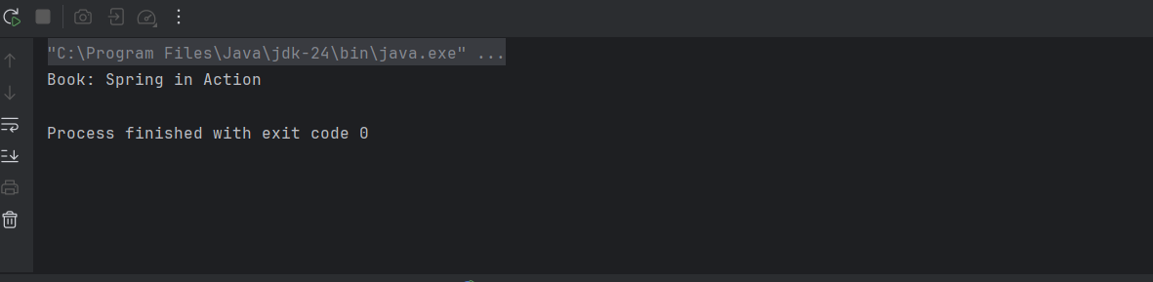

**Exercise 4: Creating and Configuring a Maven Project**

**Scenario:**

You need to set up a new Maven project for the library management application and add Spring dependencies.

**pom.xml**

<project xmlns="http://maven.apache.org/POM/4.0.0"

xmlns:xsi="http://www.w3.org/2001/XMLSchema-instance"

xsi:schemaLocation="http://maven.apache.org/POM/4.0.0 http://maven.apache.org/xsd/maven-4.0.0.xsd">

<modelVersion>4.0.0</modelVersion>

<groupId>com.library</groupId>

<artifactId>LibraryManagement</artifactId>

<version>1.0-SNAPSHOT</version>

<properties>

<maven.compiler.source>1.8</maven.compiler.source>

<maven.compiler.target>1.8</maven.compiler.target>

</properties>

<dependencies>

<dependency>

<groupId>org.springframework</groupId>

<artifactId>spring-context</artifactId>

<version>6.0.12</version>

</dependency>

<dependency>

<groupId>org.springframework</groupId>

<artifactId>spring-webmvc</artifactId>

<version>6.0.12</version>

</dependency>

<dependency>

<groupId>org.springframework</groupId>

<artifactId>spring-aop</artifactId>

<version>6.0.12</version>

</dependency>

</dependencies>

</project>

**BookRepository.java**

package com.library.repository;

public class BookRepository {

public String getBookName() {

return "Spring in Action";

}

}

**BookService.java**

package com.library.service;

import com.library.repository.BookRepository;

public class BookService {

private BookRepository bookRepository;

public void setBookRepository(BookRepository bookRepository) {

this.bookRepository = bookRepository;

}

public void displayBooks() {

System.out.println("Book: " + bookRepository.getBookName());

}

}

**LibraryManagementApplication.java**

package com.library;

import com.library.service.BookService;

import org.springframework.context.ApplicationContext;

import org.springframework.context.support.ClassPathXmlApplicationContext;

public class LibraryManagementApplication {

public static void main(String[] args) {

ApplicationContext context = new ClassPathXmlApplicationContext("applicationContext.xml");

BookService service = (BookService) context.getBean("bookService");

service.displayBooks();

}

}

**applicationContext.xml**

<?xml version="1.0" encoding="UTF-8"?>

<beans xmlns="http://www.springframework.org/schema/beans"

xmlns:xsi="http://www.w3.org/2001/XMLSchema-instance"

xsi:schemaLocation="

http://www.springframework.org/schema/beans

https://www.springframework.org/schema/beans/spring-beans.xsd">

<bean id="bookRepository" class="com.library.repository.BookRepository"/>

<bean id="bookService" class="com.library.service.BookService">

<property name="bookRepository" ref="bookRepository"/>

</bean>

</beans>

**OUTPUT:**

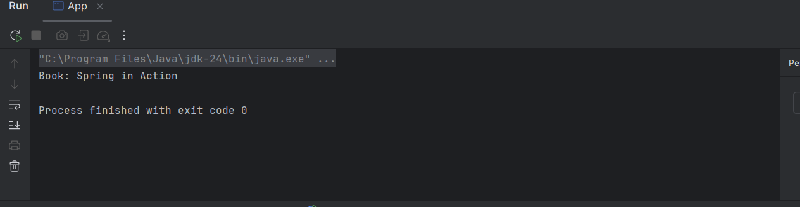

**Exercise 5: Configuring the Spring IoC Container**

**Scenario:**

The library management application requires a central configuration for beans and dependencies.

**BookRepository.java**

package com.library.repository;

public class BookRepository {

public String getBookName() {

return "Spring in Action";

}

}

**BookService.java**

package com.library.service;

import com.library.repository.BookRepository;

public class BookService {

private BookRepository bookRepository;

public void setBookRepository(BookRepository bookRepository) {

this.bookRepository = bookRepository;

}

public void displayBooks() {

System.out.println("Book Retrieved from Repository: \"" + bookRepository.getBookName() + "\"");

}

}

**App.java (main class)**

package com.library;

import com.library.service.BookService;

import org.springframework.context.ApplicationContext;

import org.springframework.context.support.ClassPathXmlApplicationContext;

public class App {

public static void main(String[] args) {

ApplicationContext context = new ClassPathXmlApplicationContext("applicationContext.xml");

BookService bookService = (BookService) context.getBean("bookService");

bookService.displayBooks();

}

}

**applicationContext.xml**

<?xml version="1.0" encoding="UTF-8"?>

<beans xmlns="http://www.springframework.org/schema/beans"

xmlns:xsi="http://www.w3.org/2001/XMLSchema-instance"

xsi:schemaLocation="

http://www.springframework.org/schema/beans

https://www.springframework.org/schema/beans/spring-beans.xsd">

<bean id="bookRepository" class="com.library.repository.BookRepository" />

<bean id="bookService" class="com.library.service.BookService">

<property name="bookRepository" ref="bookRepository"/>

</bean>

</beans>

**OUTPUT:**

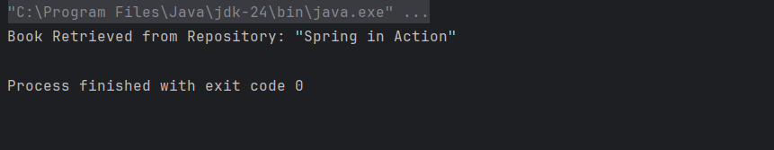

**Exercise 7: Implementing Constructor and Setter Injection**

**Scenario:**

The library management application requires both constructor and setter injection for better control over bean initialization.

**BookRepository.java**

package com.library.repository;  
public class BookRepository {  
 public String getBookName() {  
 return "Effective Java";  
 }  
}

**BookService.java**

package com.library.service;  
import com.library.repository.BookRepository;  
public class BookService {  
 private BookRepository bookRepository;  
 private String libraryName;  
 public BookService(String libraryName) {  
 this.libraryName = libraryName;  
 }  
 public void setBookRepository(BookRepository bookRepository) {  
 this.bookRepository = bookRepository;  
 }  
 public void displayBooks() {  
 System.*out*.println("Welcome to " + libraryName + " Library!");  
 System.*out*.println("Book available: " + bookRepository.getBookName());  
 }  
}

**App.java**

package com.library;  
import com.library.service.BookService;  
import org.springframework.context.ApplicationContext;  
import org.springframework.context.support.ClassPathXmlApplicationContext;  
public class App {  
 public static void main(String[] args) {  
 ApplicationContext context = new ClassPathXmlApplicationContext("applicationContext.xml");  
 BookService bookService = (BookService) context.getBean("bookService");  
 bookService.displayBooks();  
 }  
}

**applicationContext.xml**

<?xml version="1.0" encoding="UTF-8"?>  
<beans xmlns="http://www.springframework.org/schema/beans"  
 xmlns:xsi="http://www.w3.org/2001/XMLSchema-instance"  
 xsi:schemaLocation="  
 http://www.springframework.org/schema/beans  
 https://www.springframework.org/schema/beans/spring-beans.xsd">  
 <bean id="bookRepository" class="com.library.repository.BookRepository"/>  
 <bean id="bookService" class="com.library.service.BookService">  
 <constructor-arg value="Central City"/>  
 <property name="bookRepository" ref="bookRepository"/>  
 </bean>  
</beans>

**OUTPUT:**

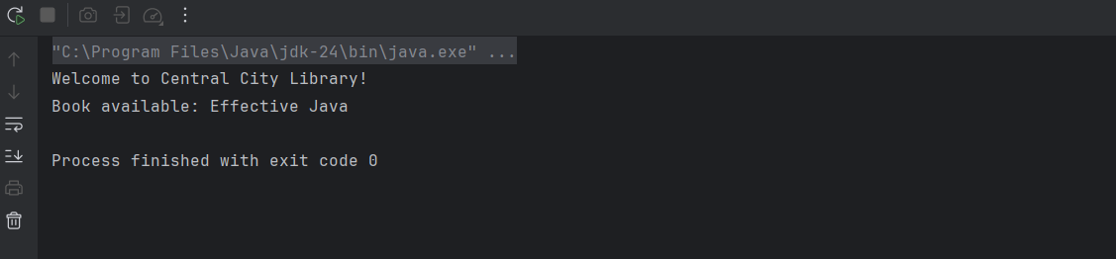

**Exercise 9: Creating a Spring Boot Application**

**Scenario:**

You need to create a Spring Boot application for the library management system to simplify configuration and deployment.

**1. Book.java – Model**

package com.libraryapp.librarybootapp.model;

import jakarta.persistence.*;

@Entity

public class Book {

@Id

@GeneratedValue(strategy = GenerationType.IDENTITY)

private Long id;

private String title;

private String author;

public Book() {}

public Book(String title, String author) {

this.title = title;

this.author = author;

}

public Long getId() { return id; }

public void setId(Long id) { this.id = id; }

public String getTitle() { return title; }

public void setTitle(String title) { this.title = title; }

public String getAuthor() { return author; }

public void setAuthor(String author) { this.author = author; }

}

**2. BookRepository.java – JPA Repository**

package com.libraryapp.librarybootapp.repository;

import com.libraryapp.librarybootapp.model.Book;

import org.springframework.data.jpa.repository.JpaRepository;

public interface BookRepository extends JpaRepository<Book, Long> {

}

**3. BookController.java – REST API Controller**

package com.libraryapp.librarybootapp.controller;

import com.libraryapp.librarybootapp.model.Book;

import com.libraryapp.librarybootapp.repository.BookRepository;

import org.springframework.beans.factory.annotation.Autowired;

import org.springframework.web.bind.annotation.*;

import java.util.List;

@RestController

@RequestMapping("/books")

public class BookController {

@Autowired

private BookRepository bookRepository;

@GetMapping

public List<Book> getAllBooks() {

return bookRepository.findAll();

}

@PostMapping

public Book addBook(@RequestBody Book book) {

return bookRepository.save(book);

}

@GetMapping("/{id}")

public Book getBookById(@PathVariable Long id) {

return bookRepository.findById(id).orElse(null);

}

@PutMapping("/{id}")

public Book updateBook(@PathVariable Long id, @RequestBody Book updatedBook) {

return bookRepository.findById(id).map(book -> {

book.setTitle(updatedBook.getTitle());

book.setAuthor(updatedBook.getAuthor());

return bookRepository.save(book);

}).orElse(null);

}

@DeleteMapping("/{id}")

public void deleteBook(@PathVariable Long id) {

bookRepository.deleteById(id);

}

}

**4. LibraryBootAppApplication.java – Main App Class**

package com.libraryapp.librarybootapp;

import org.springframework.boot.SpringApplication;

import org.springframework.boot.autoconfigure.SpringBootApplication;

@SpringBootApplication

public class LibraryBootAppApplication {

public static void main(String[] args) {

SpringApplication.run(LibraryBootAppApplication.class, args);

}

}

**5. application.properties – H2 DB Config**

spring.datasource.url=jdbc:h2:mem:testdb

spring.datasource.driverClassName=org.h2.Driver

spring.datasource.username=sa

spring.datasource.password=

spring.h2.console.enabled=true

spring.jpa.show-sql=true

spring.jpa.hibernate.ddl-auto=update

**Maven Dependencies (pom.xml)**

<dependencies>

<!-- Spring Boot Starter Web -->

<dependency>

<groupId>org.springframework.boot</groupId>

<artifactId>spring-boot-starter-web</artifactId>

</dependency>

<!-- Spring Boot Starter Data JPA -->

<dependency>

<groupId>org.springframework.boot</groupId>

<artifactId>spring-boot-starter-data-jpa</artifactId>

</dependency>

<!-- H2 Database -->

<dependency>

<groupId>com.h2database</groupId>

<artifactId>h2</artifactId>

<scope>runtime</scope>

</dependency>

<!-- Jakarta Persistence API -->

<dependency>

<groupId>jakarta.persistence</groupId>

<artifactId>jakarta.persistence-api</artifactId>

<version>3.1.0</version>

</dependency>

</dependencies>

**OUTPUT:**

